**Project Report: JobHub Connect   
Group – 9 ( Alpha )**

**Introduction:**

JobHub Connect is a project aimed at developing a comprehensive job board platform that aggregates job listings from various sources to provide users with a centralized hub for streamlined job search. This report outlines the project's objectives, methodology, risk analysis, and the planned tech stack for development.

**Objectives:**

* Develop a user friendly job board platform that aggregates job listings from multiple sources.
* Provide users with tools to easily browse, search, and apply for job openings.
* Enhance user experience through personalized job alerts and application management features.
* Foster a community driven environment for knowledge sharing and support among job seekers.

**Methodology:**

The project will follow an iterative development approach, incorporating feedback from stakeholders and end users throughout the development lifecycle. Agile methodologies will be employed to prioritize features, iterate on design, and ensure timely delivery of project milestones.

**Strategic Approach:**

JobHub Connect’s strategic approach involves not only the development of a robust technical infrastructure but also the strategic incorporation of user-centric features and community-building initiatives. This includes fostering collaboration among users, offering educational resources, and promoting a supportive environment for skill enhancement.

**Enhancing User Experience:**

In addition to personalized job alerts and efficient application management features, JobHub Connect aims to implement AI-driven recommendation systems. These systems will analyze user preferences, career history, and skill sets to provide tailored job suggestions, further enhancing the overall user experience.

The platform will also include interactive elements such as discussion forums, webinars, and Q&A sessions to facilitate knowledge-sharing and networking among job seekers. This community-driven approach not only contributes to a positive user experience but also promotes an environment where users can learn from each other's experiences and insights.

**Agile Development and Continuous Improvement:**

JobHub Connect will adopt an agile development methodology, ensuring adaptability to evolving user needs and industry trends. Regular sprint cycles will allow for the incorporation of new features, improvements, and bug fixes based on user feedback. This iterative process ensures that the platform stays relevant and aligned with the dynamic job market landscape.

Moreover, the platform will feature an intuitive feedback mechanism, encouraging users to share their experiences, report issues, and suggest enhancements. This collaborative approach fosters a sense of ownership among users, making them active contributors to the platform's evolution.

**Risk Analysis:**

**1. Data Inaccuracies and Outdated Listings:**

* Risk: Inaccurate or outdated job listings could undermine user trust and satisfaction.
* Plan: Implement automated data validation checks, conduct regular audits, and establish protocols for updating or removing inaccurate listings promptly.

**2. Technical Issues and Downtime:**

* Risk: Technical issues or downtime could disrupt user access and impact platform reliability.
* Plan: Continuously monitor platform performance, scalability, and implement a rapid response protocol for addressing technical issues to minimize downtime.

**3. Security Breaches and Data Privacy Concerns:**

* Risk: Security breaches or data privacy issues could compromise user data and trust.
* Plan: Employ robust security measures, conduct regular security audits, and develop an incident response plan to mitigate the impact of security breaches and protect user data.

**4. User Engagement and Adoption Challenges:**

* Risk: Challenges in user engagement and adoption could affect platform growth and success.
* Plan: Track user engagement metrics, conduct user feedback sessions, and implement targeted marketing campaigns and feature enhancements to boost user engagement.

**5. Legal and Regulatory Compliance Issues:**

* Risk: Noncompliance with legal and regulatory requirements could result in legal consequences and reputational damage.
* Plan: Stay informed about relevant laws and regulations, consult legal advisors, and update platform policies to ensure compliance with applicable laws and regulations.

**Risk Management Plan for JobHub Connect:**

**1. Risk: Data Inaccuracies and Outdated Listings**

* Monitoring: Regularly monitor the accuracy and relevance of job listings by implementing automated data validation checks and manual reviews by the moderation team.
* Reevaluation: Conduct periodic audits of the job database to identify and rectify inaccuracies or outdated listings.
* Contingency Plan: Establish protocols for quickly removing or updating inaccurate listings upon identification, and communicate with users transparently about any discrepancies.

**2. Risk: Technical Issues and Downtime**

* Monitoring: Implement continuous monitoring of the platform's performance, uptime, and responsiveness using monitoring tools and analytics.
* Reevaluation: Regularly assess the platform's technical infrastructure and scalability to accommodate increasing user traffic and mitigate potential downtime risks.
* Contingency Plan: Develop a rapid response protocol for addressing technical issues, including backup systems, failover mechanisms, and communication strategies to notify users about downtime and expected resolution timelines.

**3. Risk: Security Breaches and Data Privacy Concerns**

* **Monitoring:** Employ robust security measures such as encryption, access controls, and regular security audits to safeguard user data and prevent unauthorized access.
* **Reevaluation:** Stay updated on evolving security threats and compliance regulations related to data privacy, and adapt security protocols accordingly
* **Contingency Plan:** Develop a comprehensive incident response plan outlining steps to mitigate the impact of security breaches, including notification procedures, forensic analysis, and remediation actions to restore data integrity and user trust.

**4. Risk: User Engagement and Adoption Challenges**

* **Monitoring:** Track user engagement metrics, including site traffic, job applications, and community interactions, to gauge the platform's adoption rate and user satisfaction.
* **Reevaluation:** Conduct user surveys, feedback sessions, and usability testing to identify areas for improvement and enhance user experience.
* **Contingency Plan:** Implement targeted marketing campaigns, user incentives, and feature enhancements to boost user engagement and address any adoption challenges identified through feedback mechanisms.

**5. Risk: Legal and Regulatory Compliance Issues**

* **Monitoring:** Stay informed about relevant labor laws, employment regulations, and data protection statutes to ensure compliance with legal requirements.
* **Reevaluation:** Regularly review and update platform policies, terms of service, and privacy policies to align with changing regulatory landscapes.
* **Contingency Plan:** Consult legal advisors to address any compliance issues promptly, communicate transparently with users about policy updates, and implement necessary changes to maintain compliance with applicable laws and regulations.

By developing and implementing this risk management plan, JobHub Connect can effectively monitor, reevaluate, and address potential risks throughout its operations, ensuring a resilient and reliable platform for job seekers and employers alike.

**Tech Stack:**

* **Frontend:**
  + ReactJS: For building a responsive and interactive user interface.
  + HTML/CSS: For structuring and styling the frontend components.
  + JavaScript: For client side scripting and interactivity.
* **Backend:**
  + Python: Using frameworks like Django or Flask for backend development, data processing, and API integrations.
  + PostgreSQL or MySQL: For storing job listings and user data.
  + RESTful APIs: For facilitating communication between the frontend and backend components.
* **Deployment:**
  + AWS (Amazon Web Services) or Heroku: For hosting and deploying the application.
  + Docker: For containerization and ensuring consistency across different environments.
  + Nginx: For serving static files and load balancing.

**Team members Description:**

|  |  |  |  |
| --- | --- | --- | --- |
| **Member name** | **Contribution description** | **Overall Contribution (%)** | **Note**  **(if applicable)** |
| Abhishek, Sharavani | Responsible for building user interface with ReactJS | 100% |  |
| Sai Venkata | Assists in frontend development tasks | 100% |  |
| Sai Nithin,  Sai Venkata | Leads backend development using Python and Django or Flask | 100% |  |
| Keerthi | Supports backend development tasks | 100% |  |
| Sai Nithin,  Keerthi | Manages database setup and optimization | 100% |  |
| Pavan Kalyan, Uday Kalyan | Handies deployment, infrastructure, and server management | 100% |  |
| Uday Kalyan,  Pavan Kalyan | Conducts testing and ensures product quality | 100% |  |

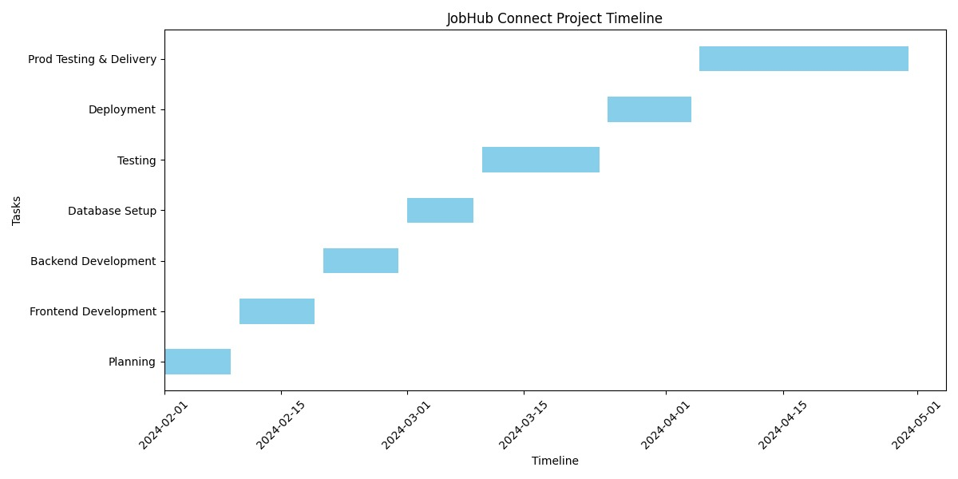

**Conclusion:**

JobHub Connect aims to revolutionize the job search process by providing users with a centralized platform for exploring diverse job opportunities. By addressing potential risks through proactive risk analysis and mitigation strategies, and leveraging a Python and ReactJSbased tech stack, the project is poised for successful development and deployment.

This project report outlines the key objectives, methodology, risk analysis, and planned tech stack for JobHub Connect, providing a comprehensive overview of the project's scope and approach.